Enterprise Software Platforms

HW #7 - Security

**Team (Technocrats)**

Vijaylaxmi Nagurkar

Monica Dommaraju

Sruthi Chilukuri

Geethu Padachery

## Creating PKI Certificates

cd pki-example-1

Root CA

mkdir -p ca/root-ca/private ca/root-ca/db crl certs

chmod 700 ca/root-ca/private

Database

cp /dev/null ca/root-ca/db/root-ca.db

cp /dev/null ca/root-ca/db/root-ca.db.attr

echo 01 > ca/root-ca/db/root-ca.crt.srl

echo 01 > ca/root-ca/db/root-ca.crl.srl

Creating the CA request

openssl req -new \

-config etc/root-ca.conf \

-out ca/root-ca.csr \

-keyout ca/root-ca/private/root-ca.key

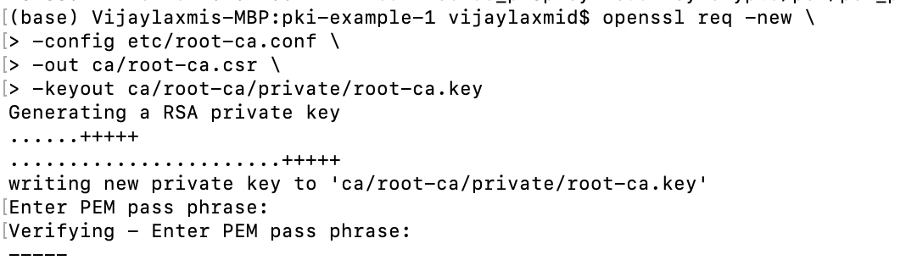

Creating the Certificate

openssl ca -selfsign \

-config etc/root-ca.conf \

-in ca/root-ca.csr \

-out ca/root-ca.crt \

-extensions root_ca_ext

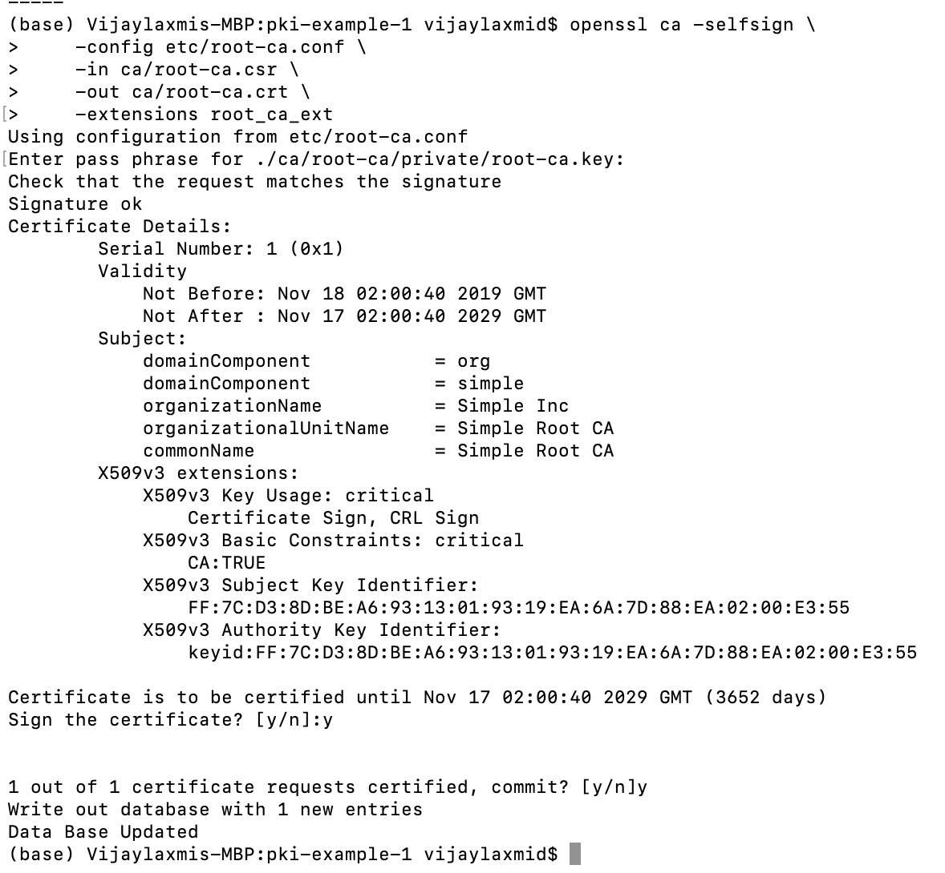

Signing CA

mkdir -p ca/signing-ca/private ca/signing-ca/db crl certs

chmod 700 ca/signing-ca/private

Database

cp /dev/null ca/signing-ca/db/signing-ca.db

cp /dev/null ca/signing-ca/db/signing-ca.db.attr

echo 01 > ca/signing-ca/db/signing-ca.crt.srl

echo 01 > ca/signing-ca/db/signing-ca.crl.srl

CA request

openssl req -new **\**

-config etc/signing-ca.conf **\**

-out ca/signing-ca.csr **\**

-keyout ca/signing-ca/private/signing-ca.key

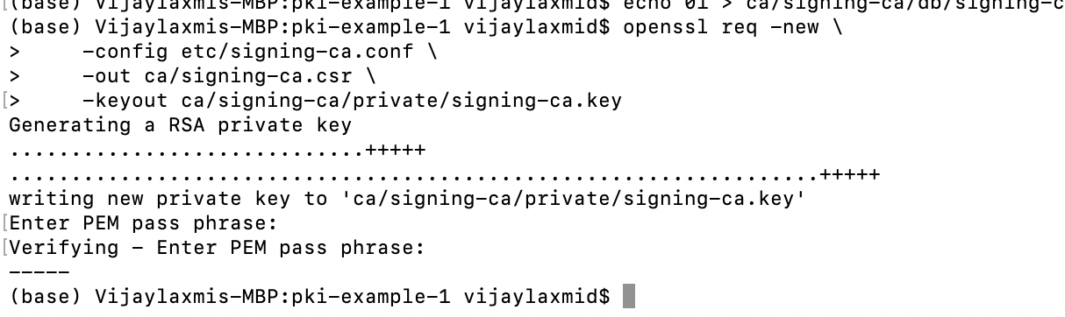

CA certificate

openssl ca **\**

-config etc/root-ca.conf **\**

-in ca/signing-ca.csr **\**

-out ca/signing-ca.crt **\**

-extensions signing_ca_ext

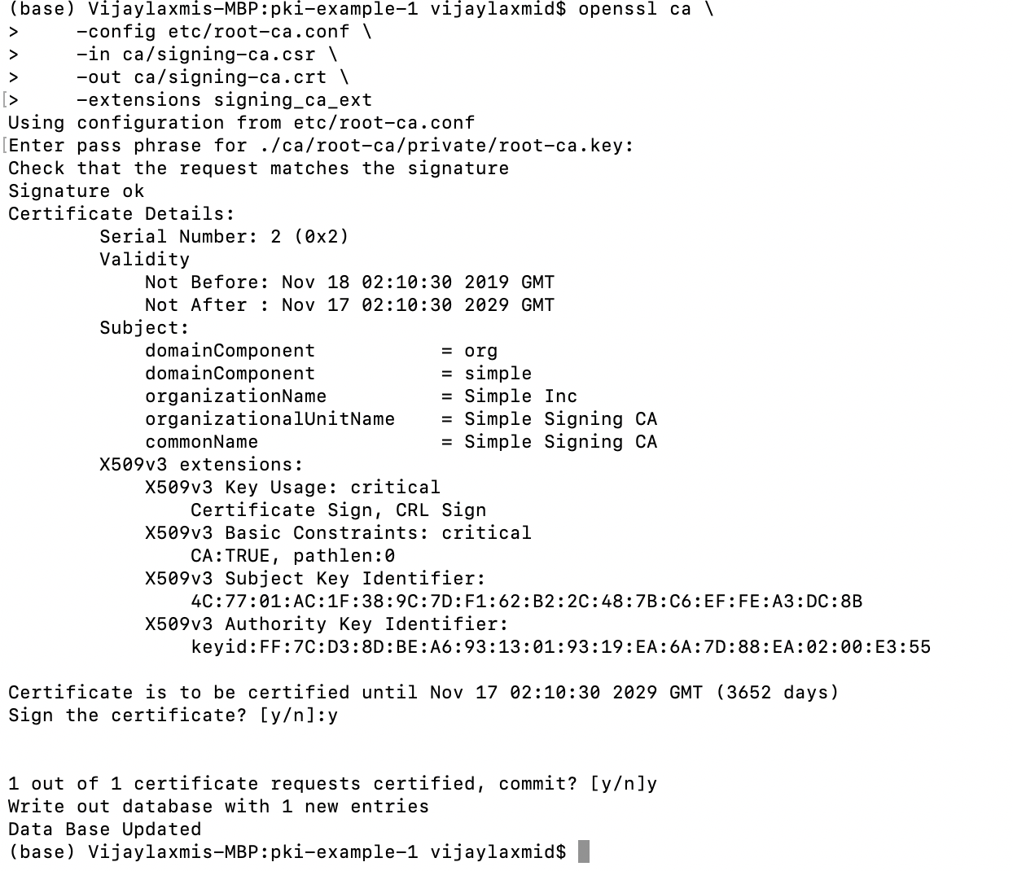

Operating the signing CA and creation of email request

openssl req -new **\**

-config etc/email.conf **\**

-out certs/fred.csr **\**

-keyout certs/fred.key

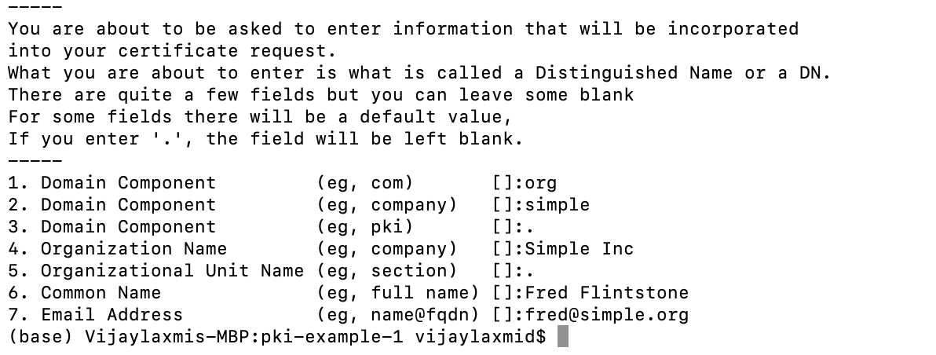

Email certificate

openssl ca **\**

-config etc/signing-ca.conf **\**

-in certs/fred.csr **\**

-out certs/fred.crt **\**

-extensions email_ext

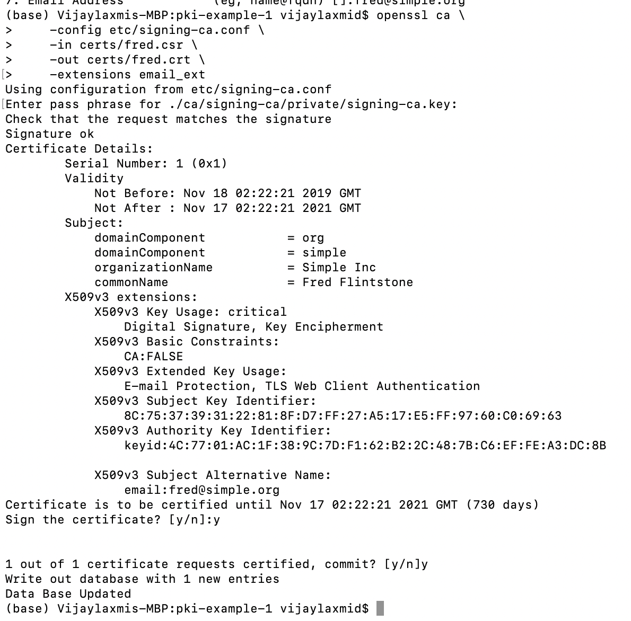

Server request fro TLS

SAN=DNS:www.simple.org **\**

openssl req -new **\**

-config etc/server.conf **\**

-out certs/simple.org.csr **\**

-keyout certs/simple.org.key

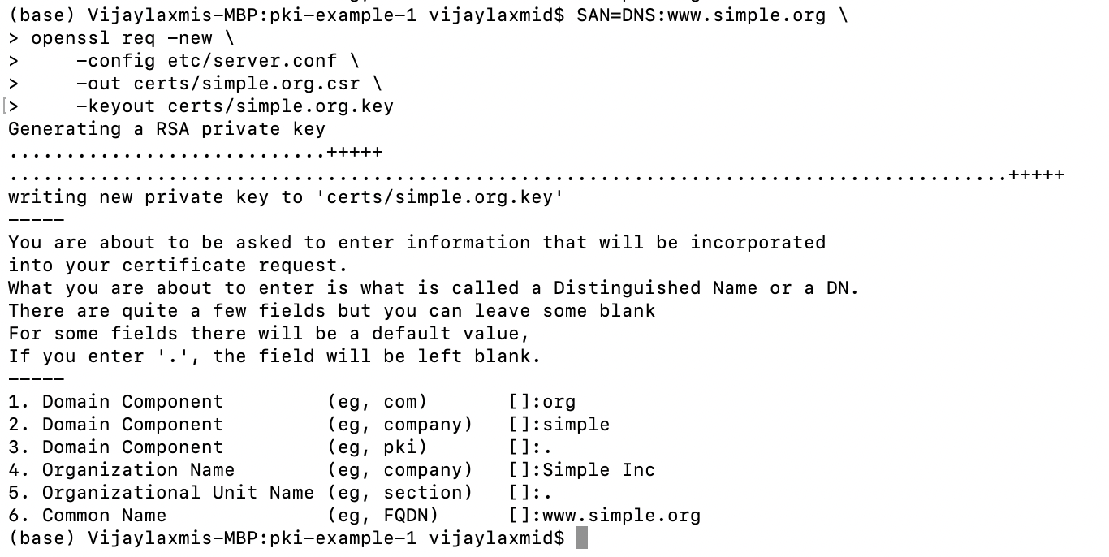

Creating the server certificate for TLS

openssl ca **\**

-config etc/signing-ca.conf **\**

-in certs/simple.org.csr **\**

-out certs/simple.org.crt **\**

-extensions server_ext

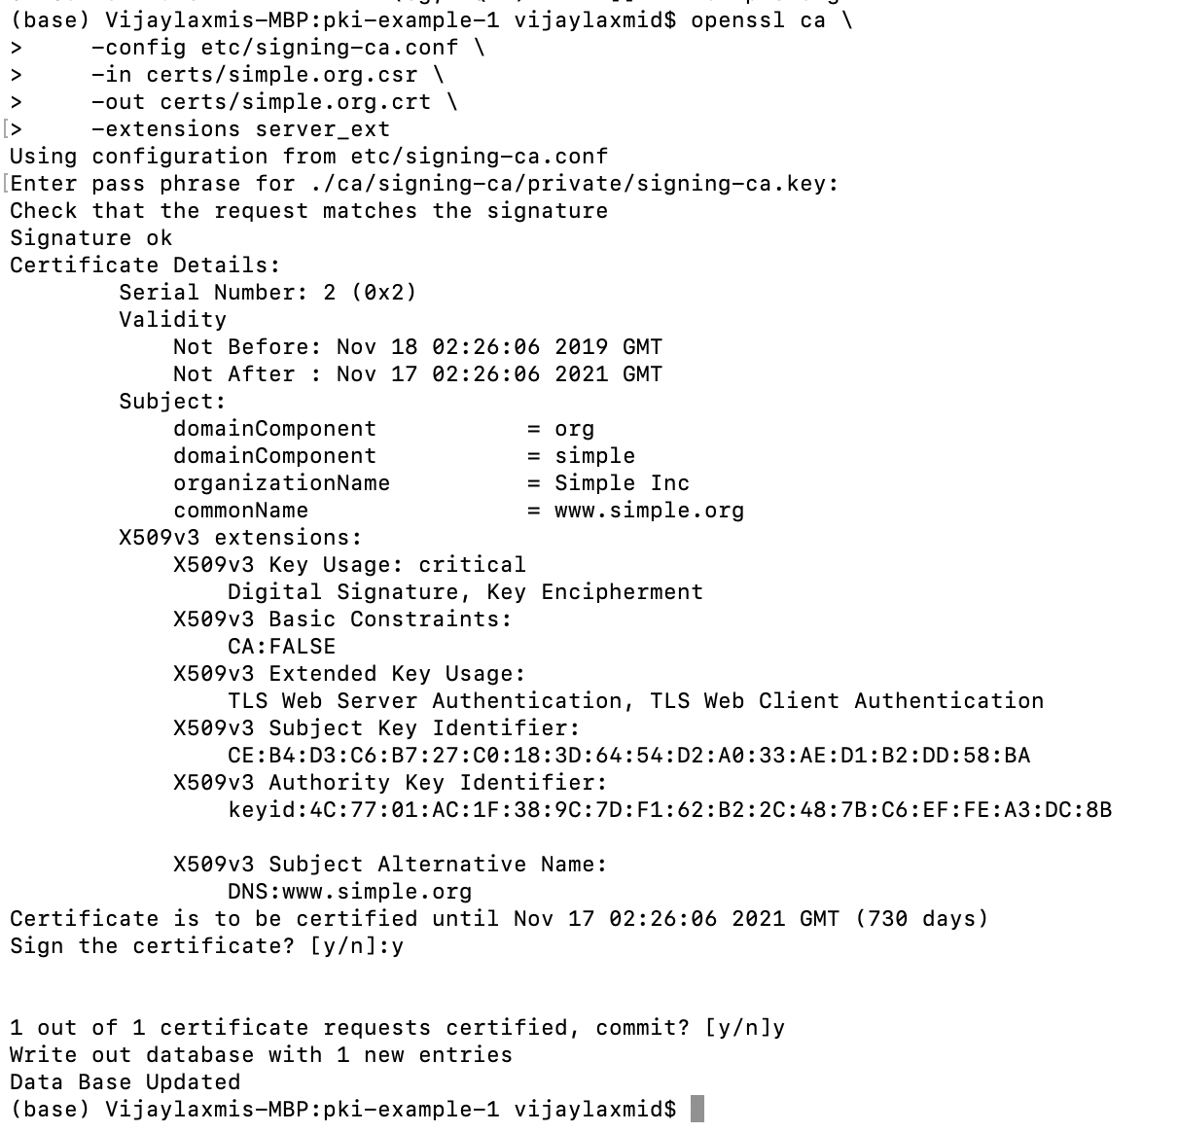

Cerrtificate Revokal

openssl ca **\**

-config etc/signing-ca.conf **\**

-revoke ca/signing-ca/01.pem **\**

-crl_reason superseded

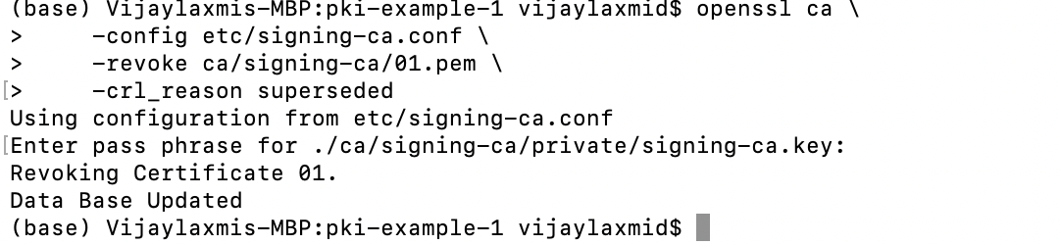

Creation of CRL

openssl ca -gencrl **\**

-config etc/signing-ca.conf **\**

-out crl/signing-ca.crl

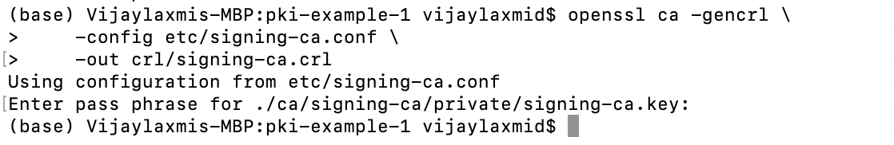

Create DER certificate

openssl x509 **\**

-in certs/fred.crt **\**

-out certs/fred.cer **\**

-outform der

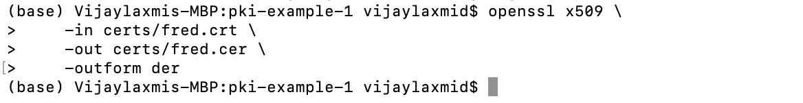

DER CRL

openssl crl **\**

-in crl/signing-ca.crl **\**

-out crl/signing-ca.crl **\**

-outform der

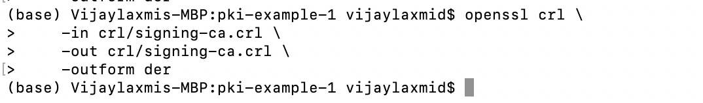

PKCS#7

openssl crl2pkcs7 -nocrl **\**

-certfile ca/signing-ca.crt **\**

-certfile ca/root-ca.crt **\**

-out ca/signing-ca-chain.p7c **\**

-outform der

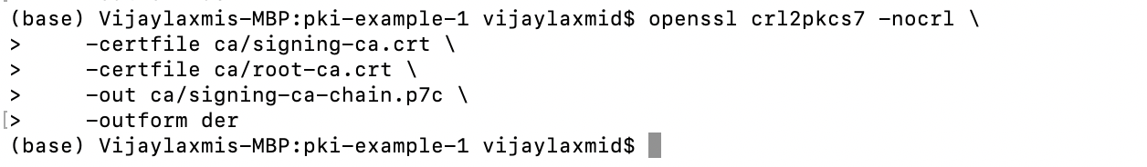

PKCS#12

openssl pkcs12 -export **\**

-name "Fred Flintstone" **\**

-inkey certs/fred.key **\**

-in certs/fred.crt **\**

-out certs/fred.p12

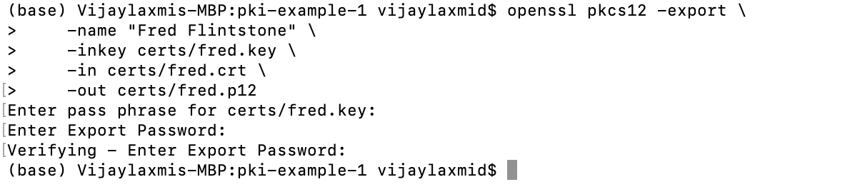

PEM

cat ca/signing-ca.crt ca/root-ca.crt > **\**

ca/signing-ca-chain.pem

cat certs/fred.key certs/fred.crt > **\**

certs/fred.pem

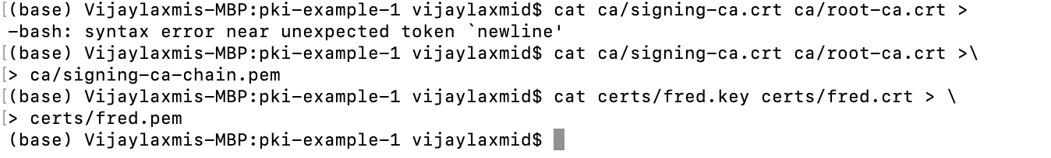

View request

openssl req **\**

-in certs/fred.csr **\**

-noout **\**

-text

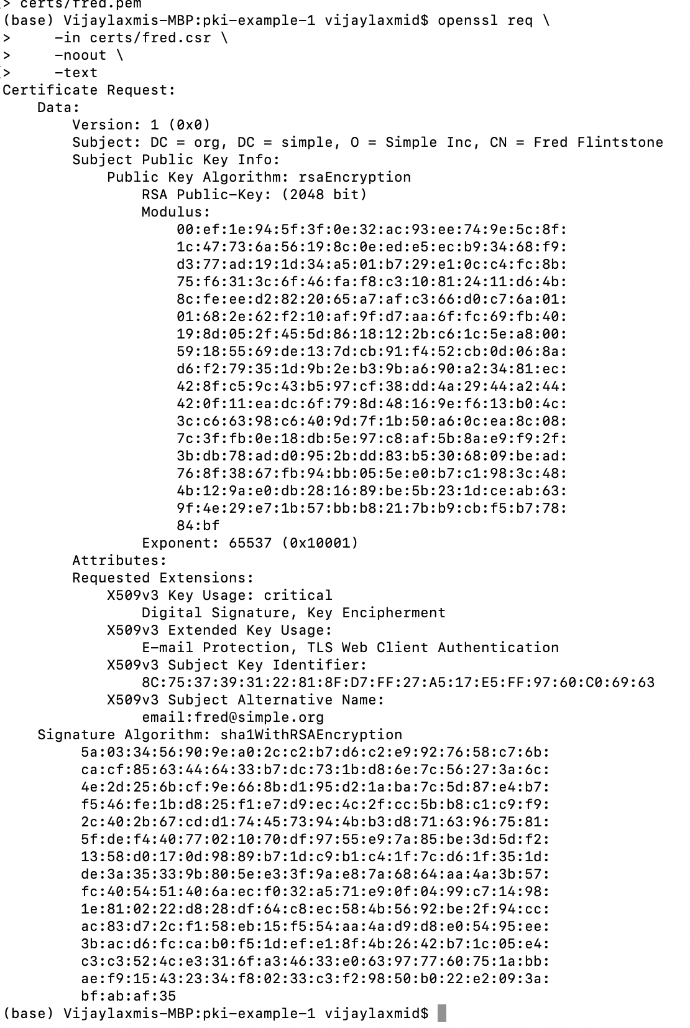

View certificate

openssl x509 **\**

-in certs/fred.crt **\**

-noout **\**

-text

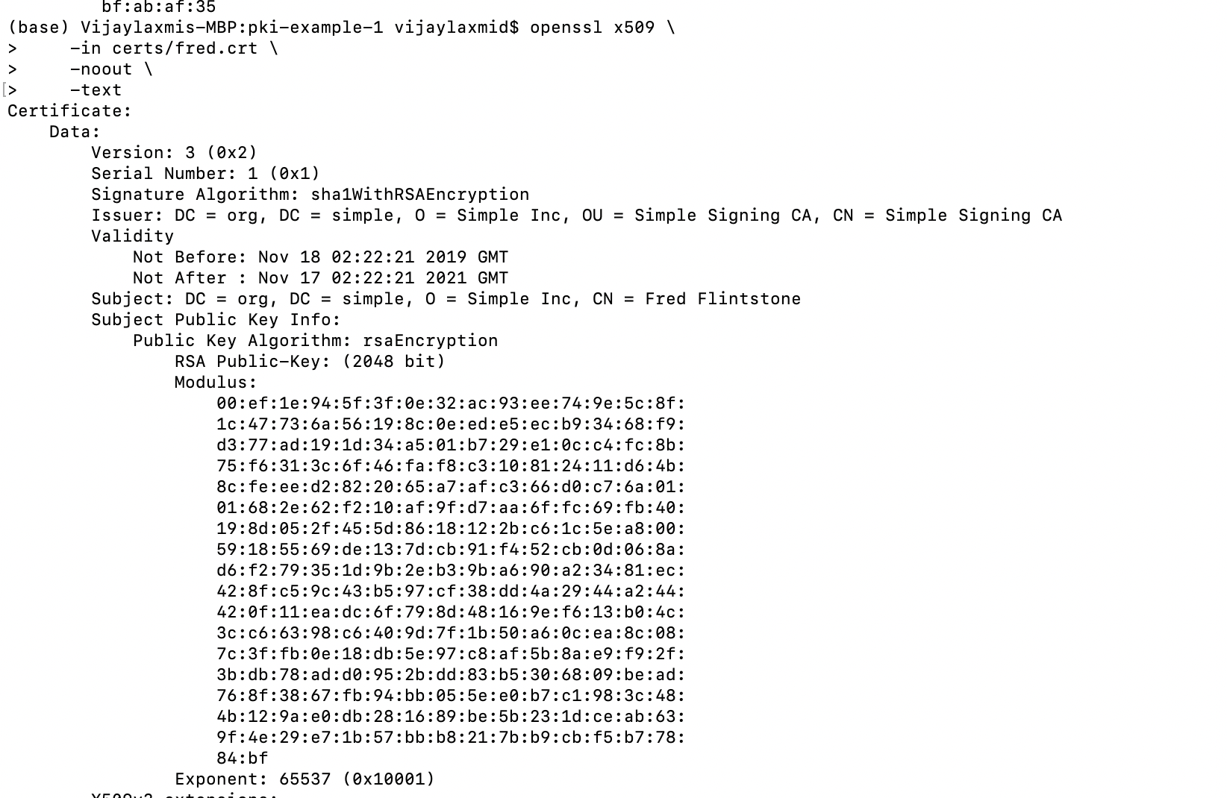

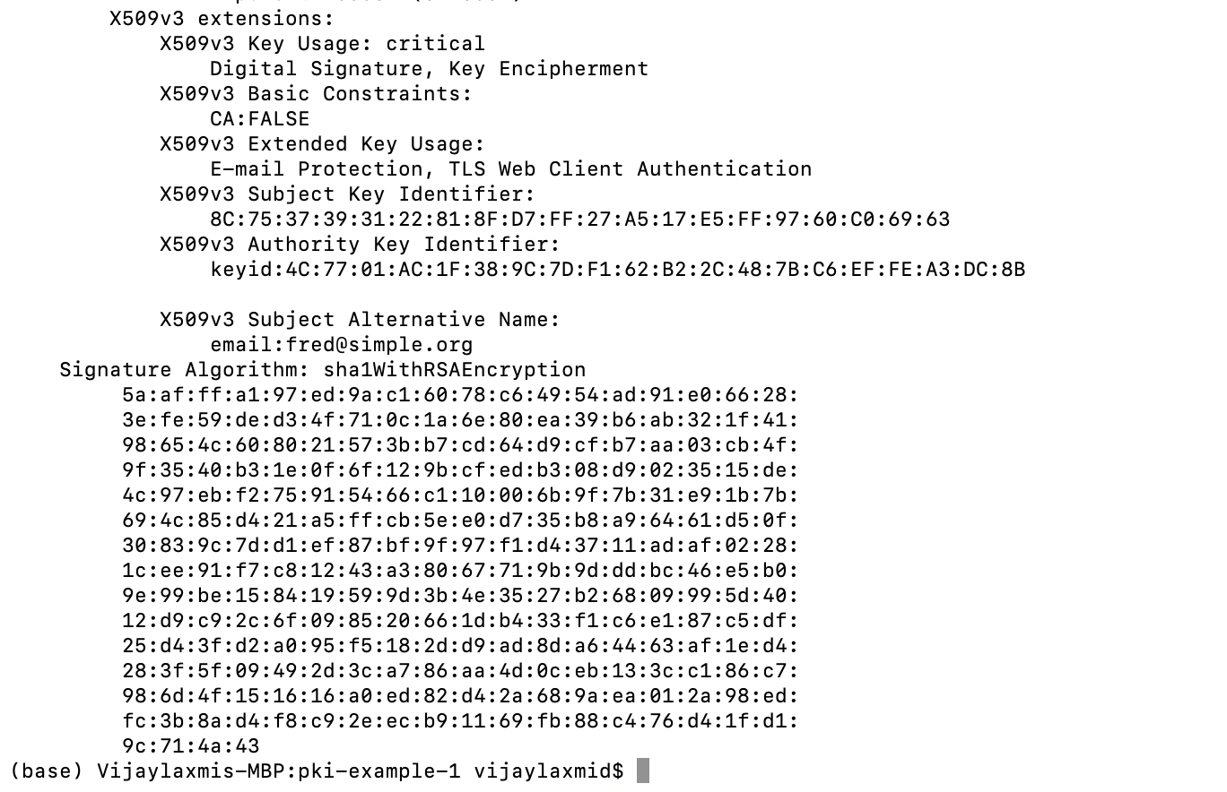

View CRL

openssl crl **\**

-in crl/signing-ca.crl **\**

-inform der **\**

-noout **\**

-text

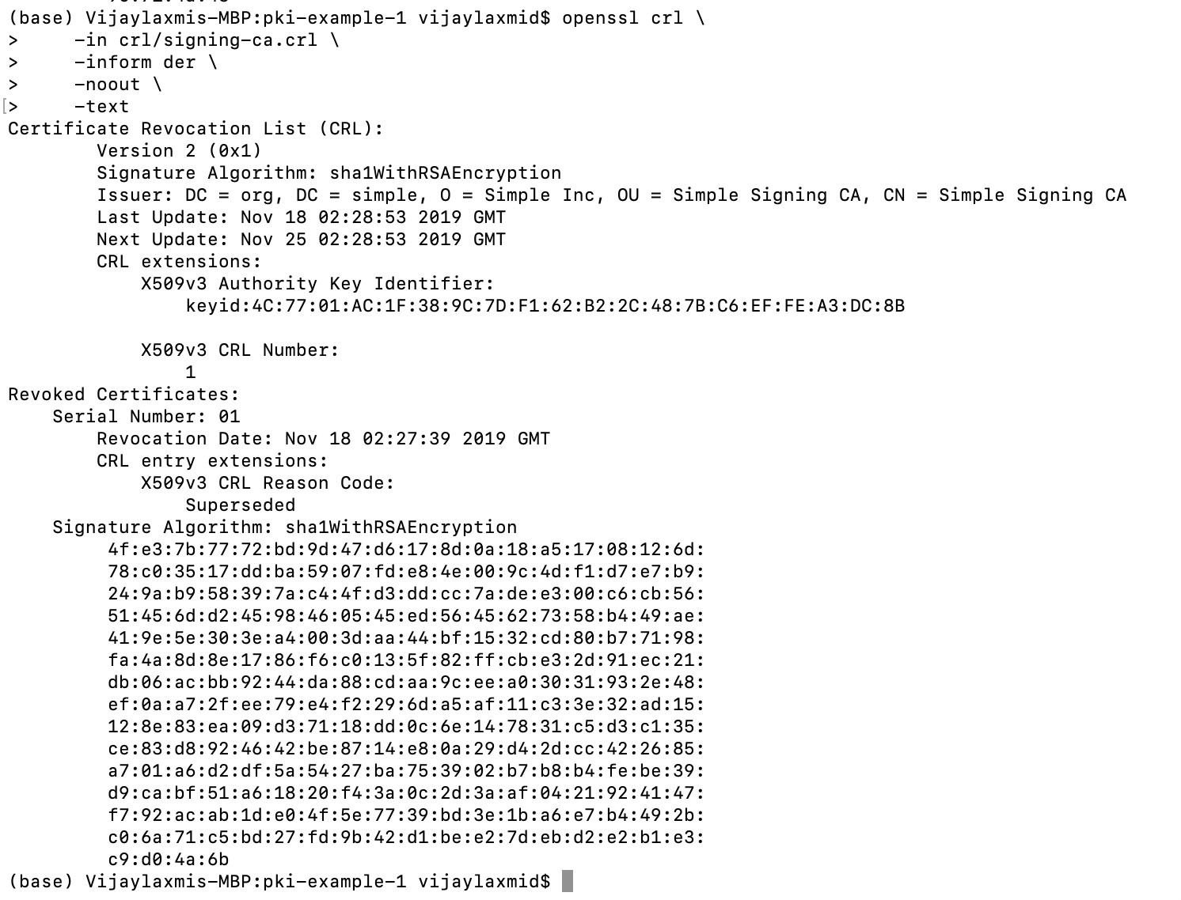

PKCS#67

openssl pkcs7 **\**

-in ca/signing-ca-chain.p7c **\**

-inform der **\**

-noout **\**

-text **\**

-print_certs

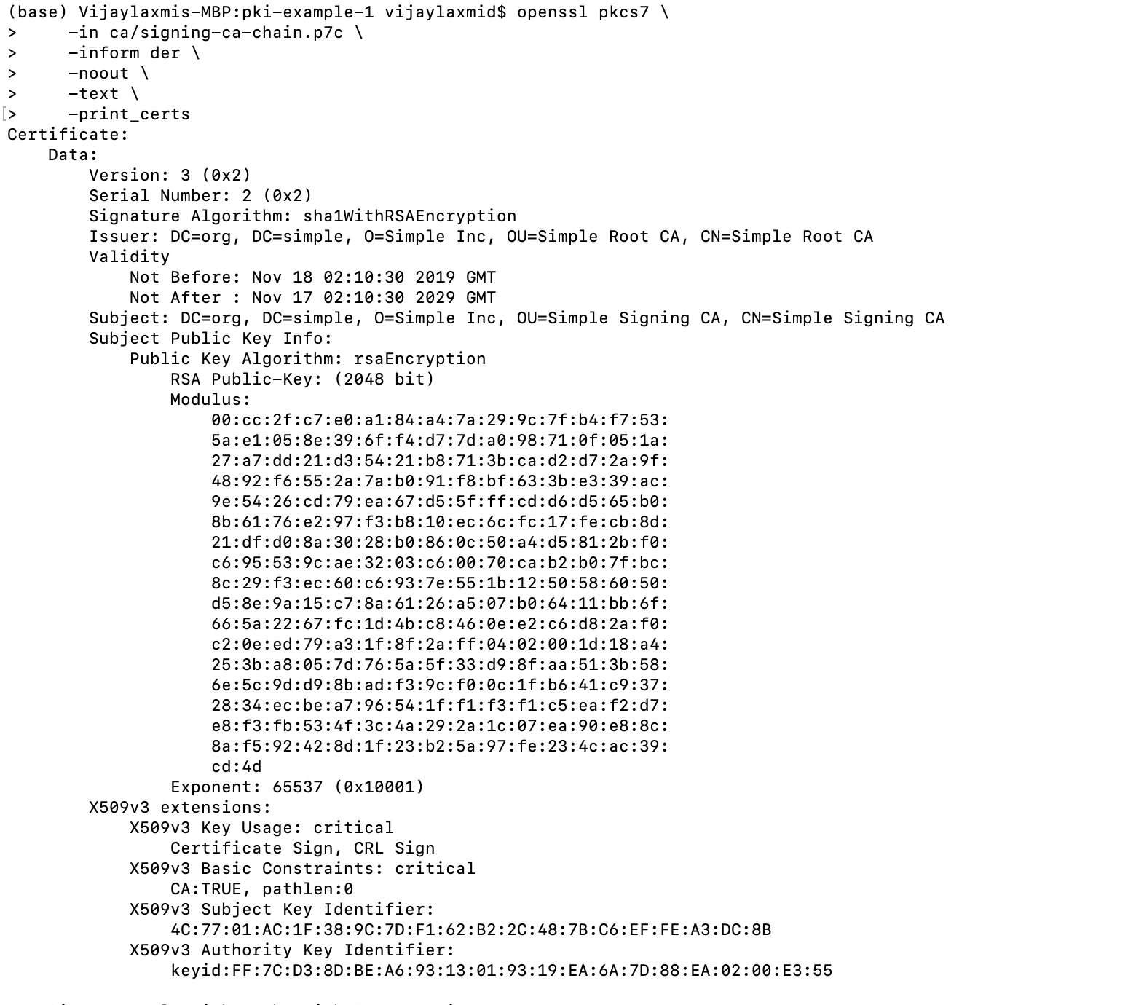

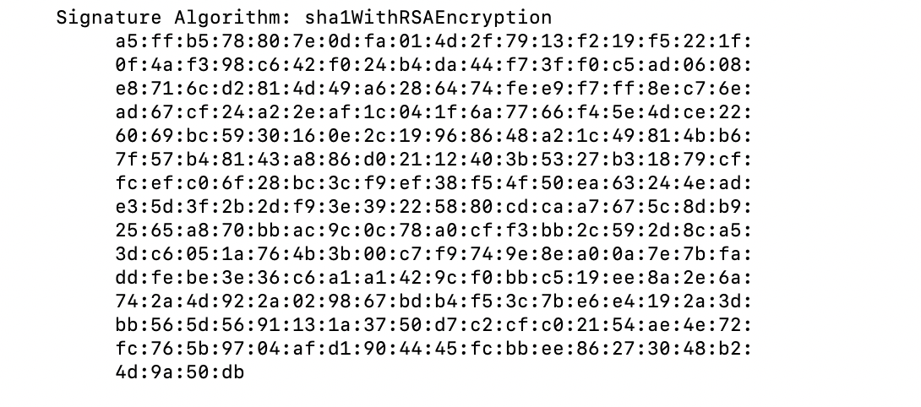

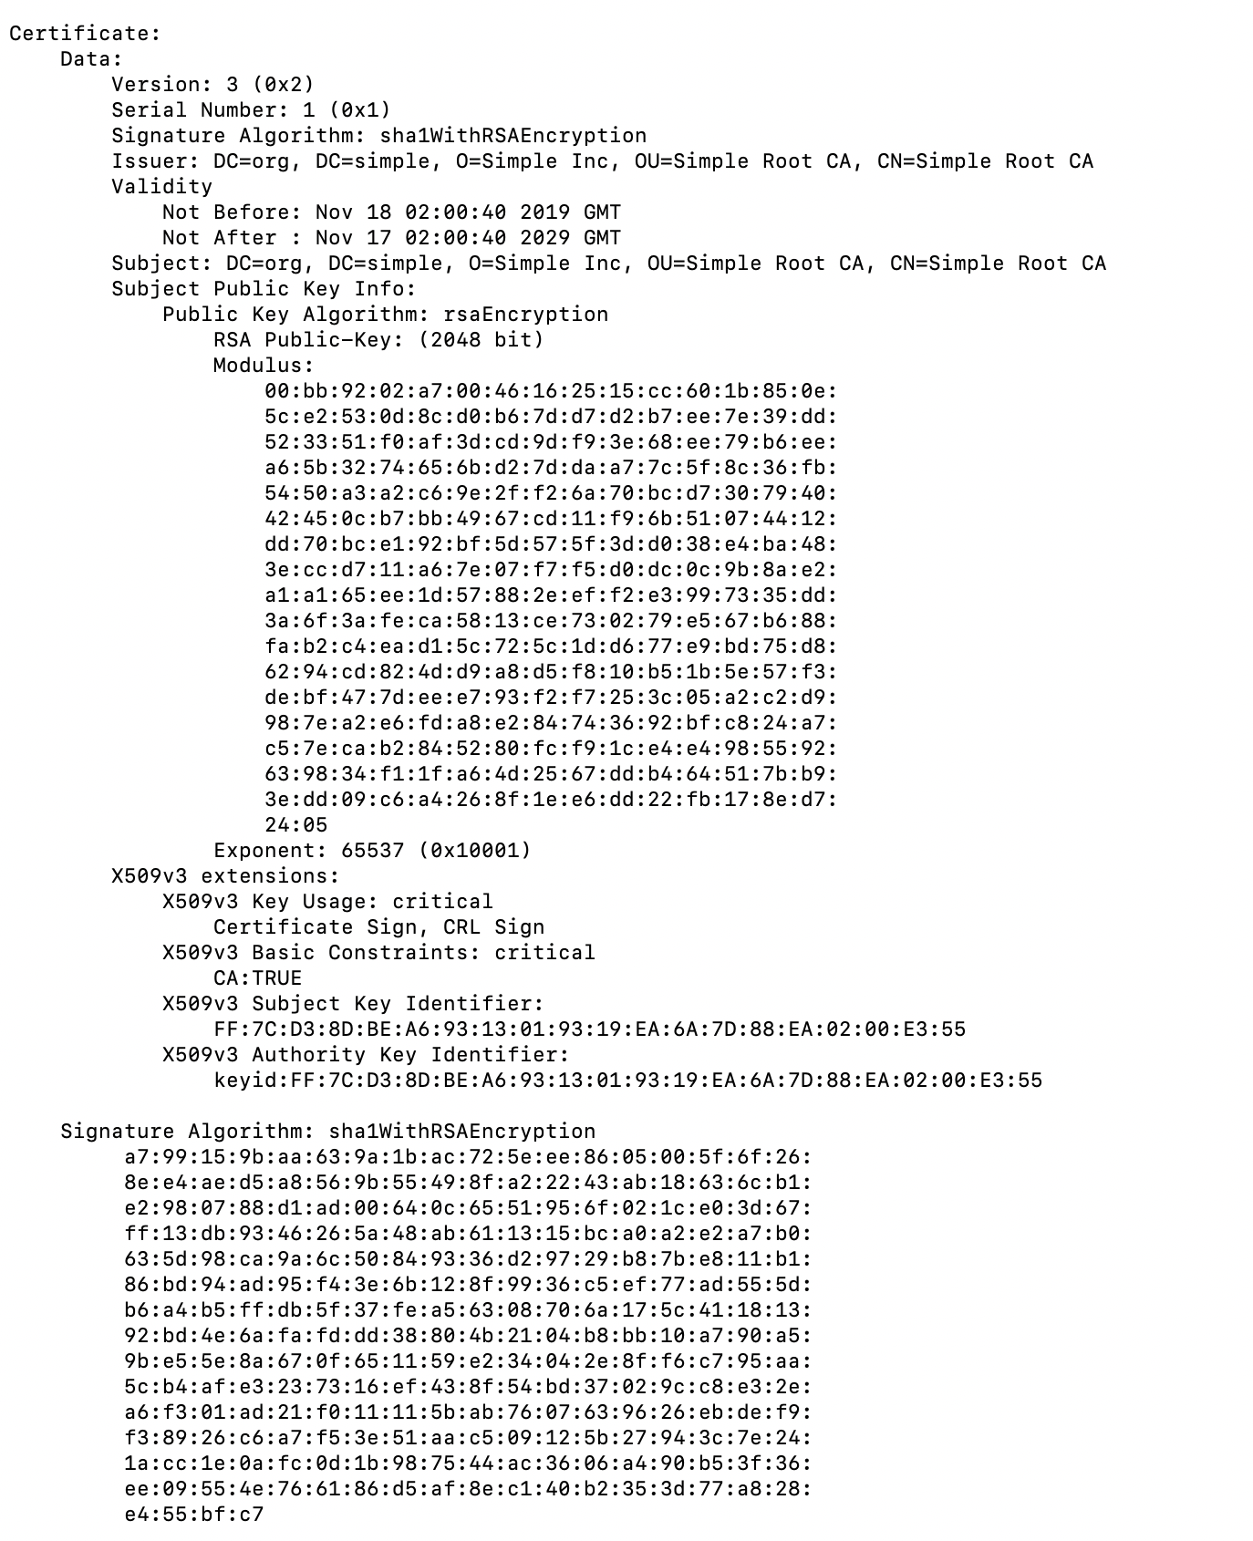

PKCS#12

openssl pkcs12 **\**

-in certs/fred.p12 **\**

-nodes **\**

-info

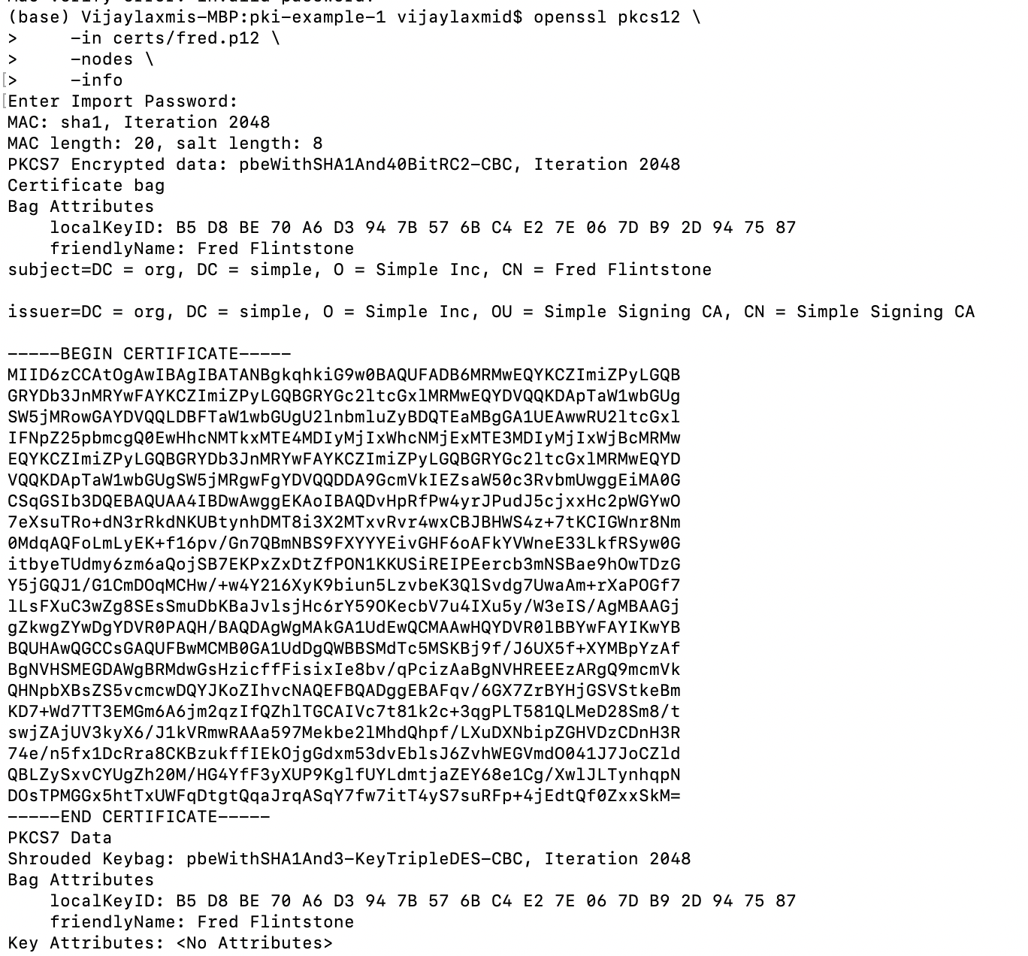

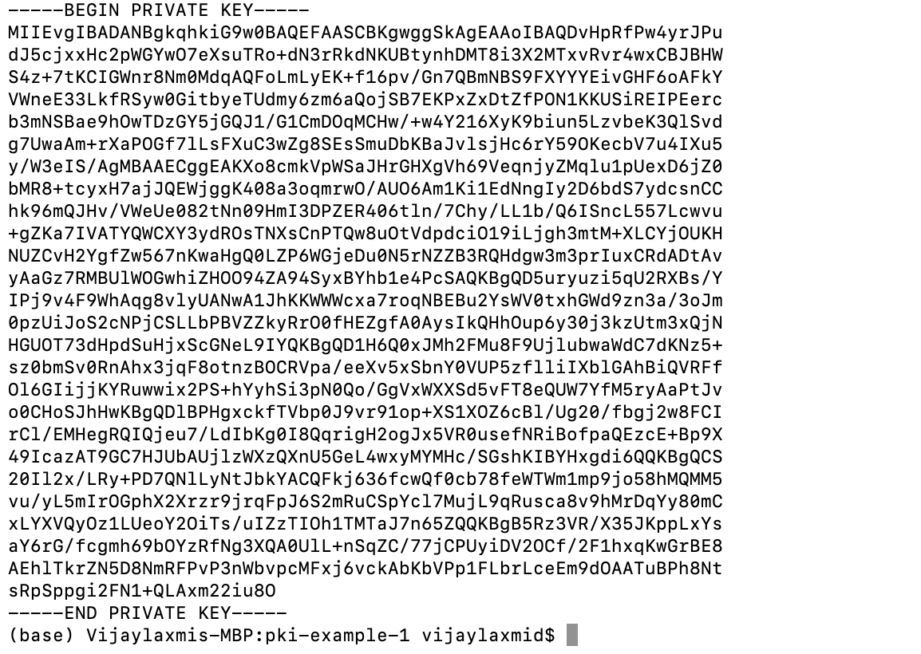

$JAVA_HOME/bin/keytool -genkey -alias tomcat -keyalg RSA

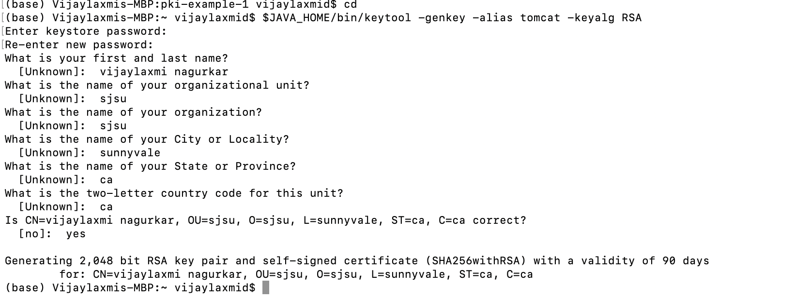

## Configuring NGINX to use the generated certificates:

* Install NGINX webserver
* Change the config to use the generated certificates

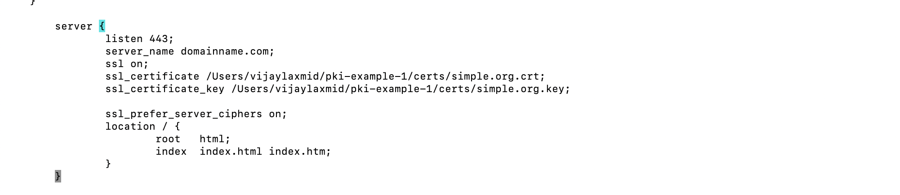

* Go to <https://localhost>

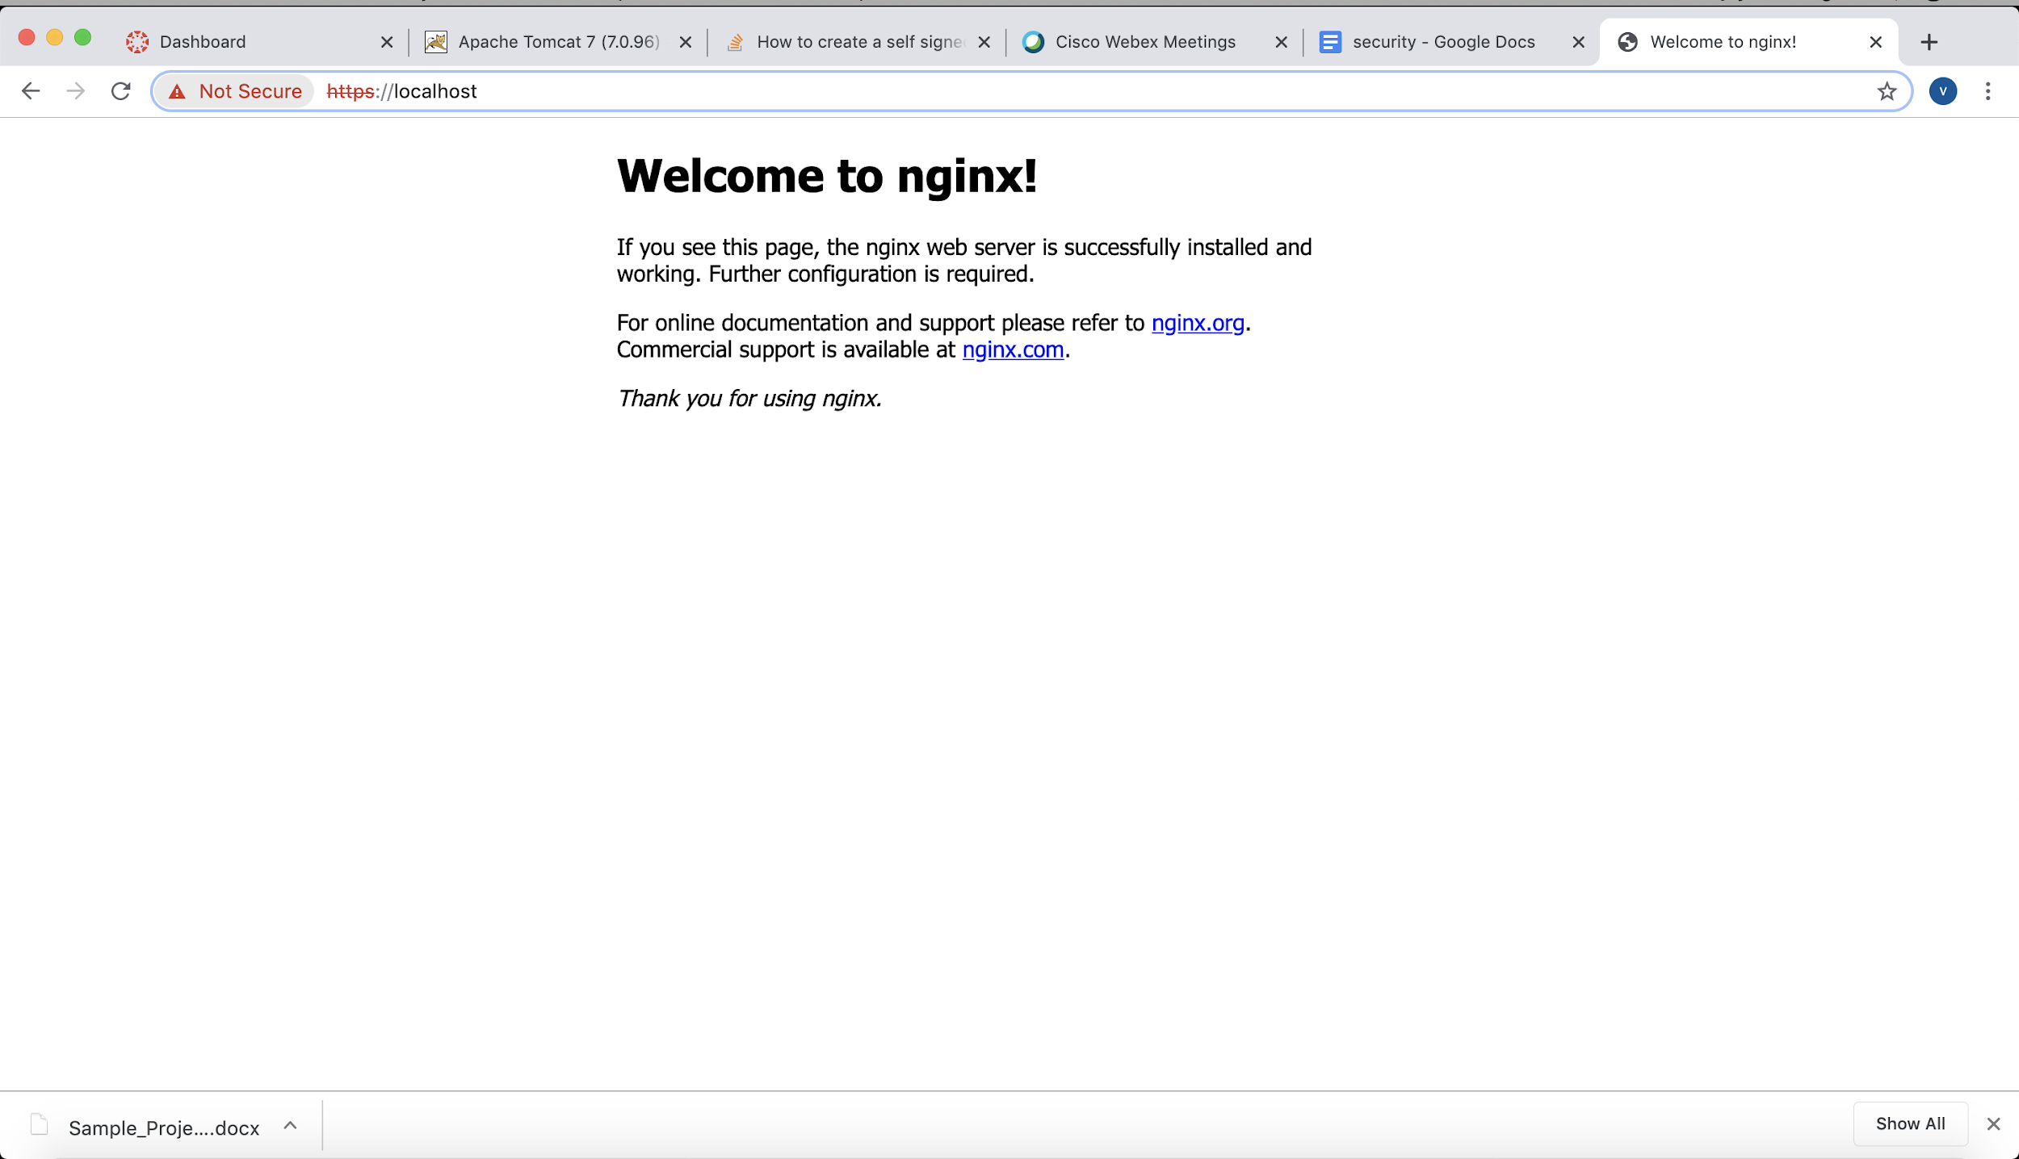

Landing page shows up on [**https://localhost**](https://localhost)

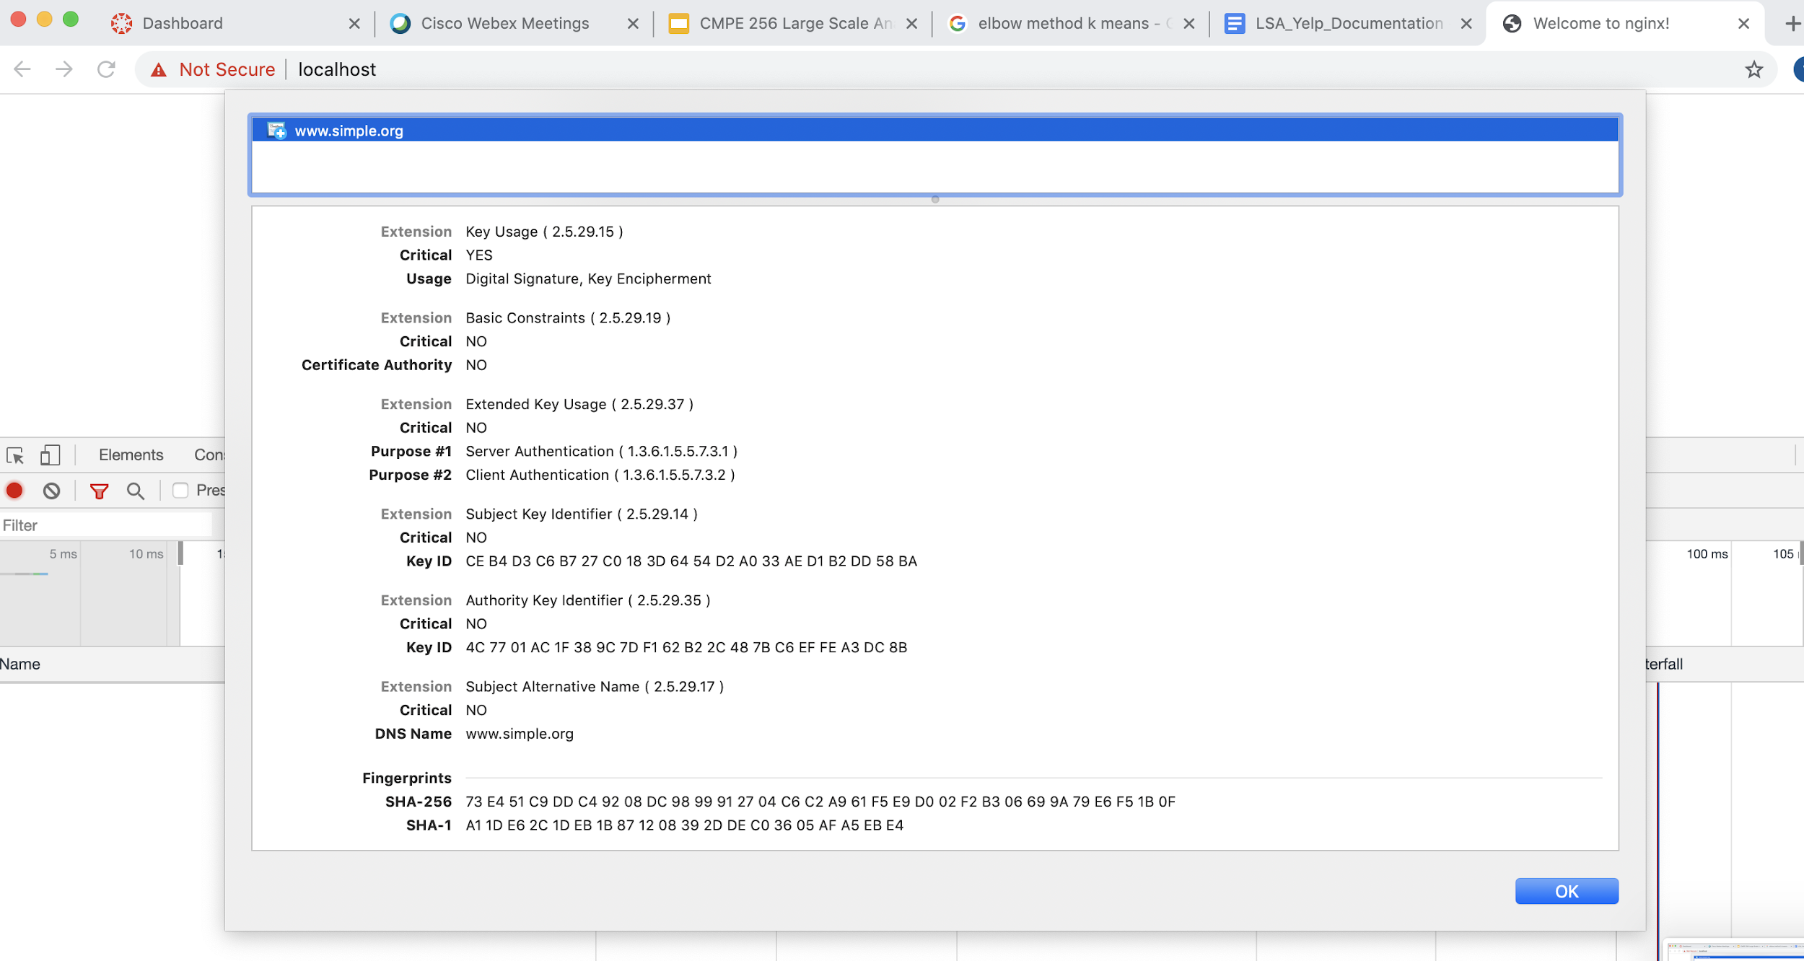

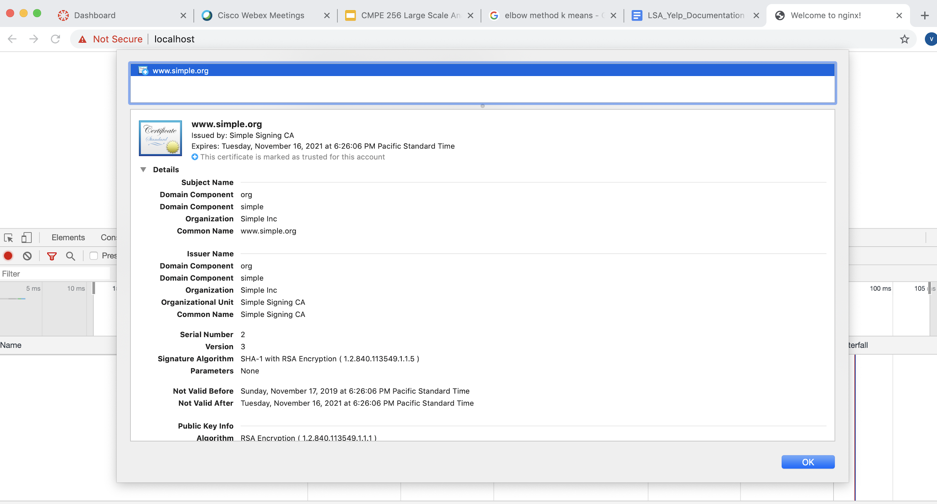

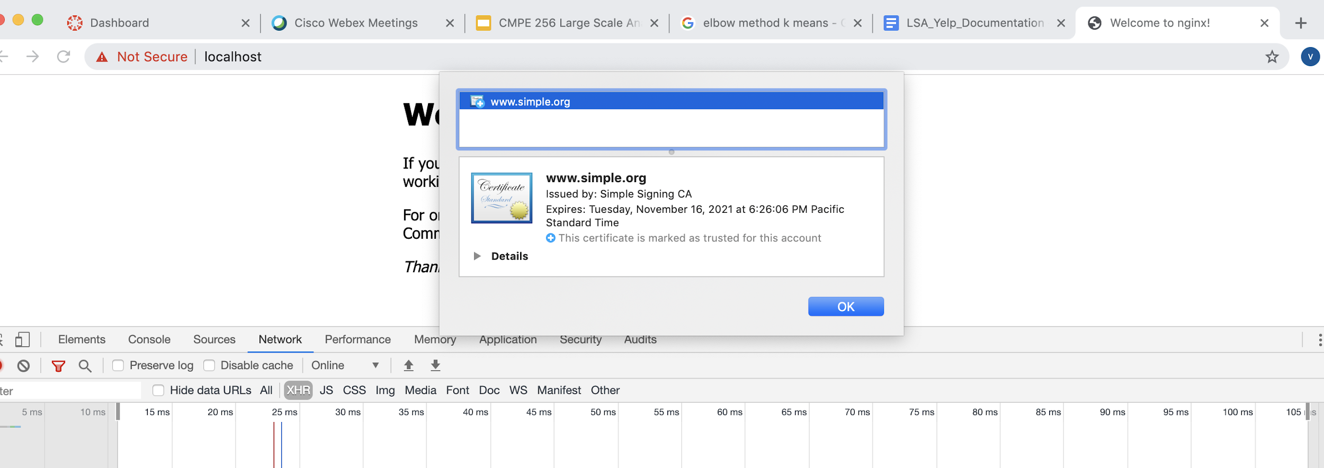

## Github Repo:

<https://github.com/vijaylaxmid/hw7-security>